Safeguarding
Keeping Adults Safe from Abuse and Neglect



Keeping people safe is called Safeguarding.

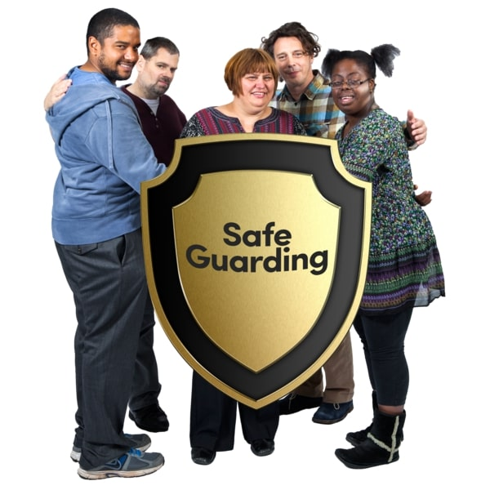
Safeguarding means people are protected from abuse and neglect.
And
People live as independently as possible and make choices about their lives.

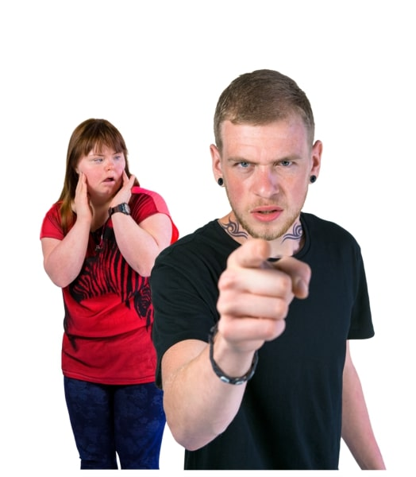
Abuse is where someone does or says things that frighten you or cause you harm.

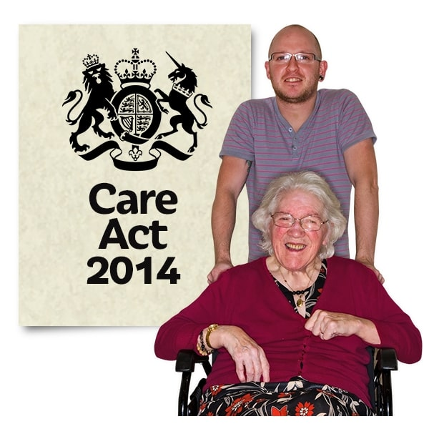
The Law says that we need to keep adults safe who are at risk of being abused.

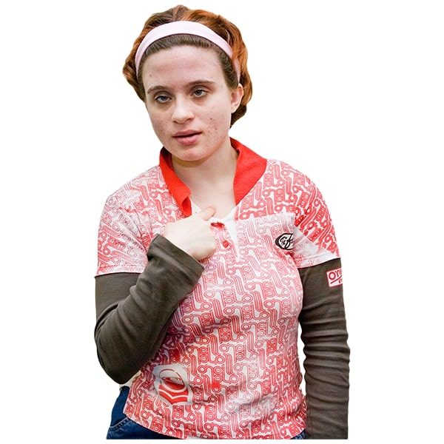
Your rights
You have the right to live your life without being abused.

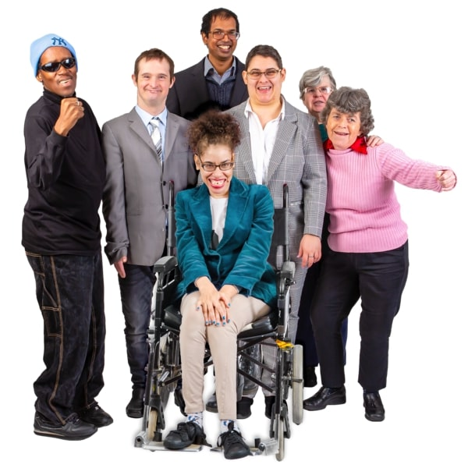

An adult at risk of harm is:
- 18 years or older.
- has care and support needs.
- this may be because of their age, disability, mental health needs, drug or alcohol misuse or other condition.
And
- they are unable to protect themselves.
This could be you, friends, family members or other adults you know.

Abuse can happen anywhere.

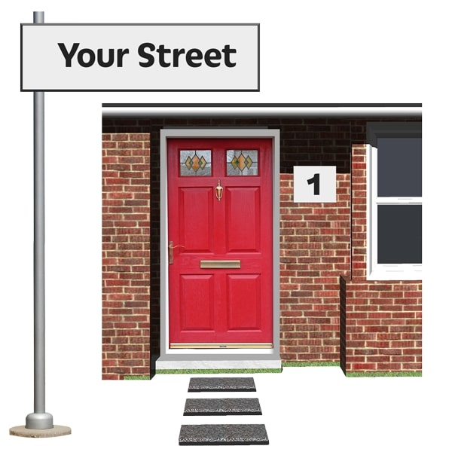
At home

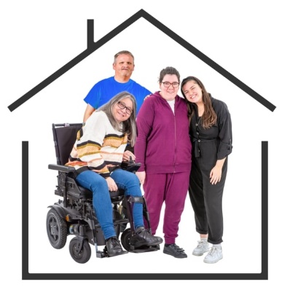
In a care or nursing home

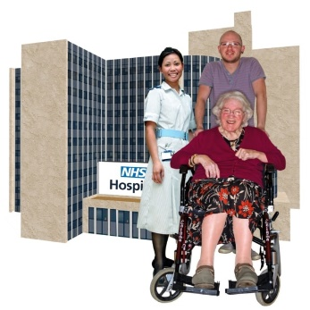
In a hospital

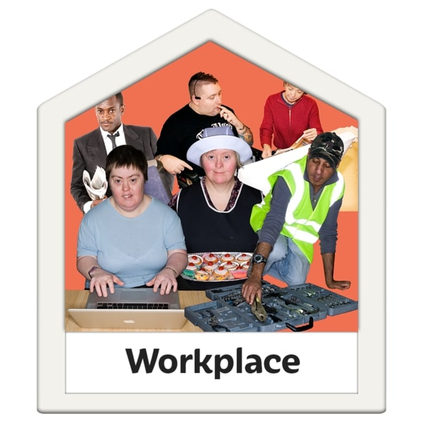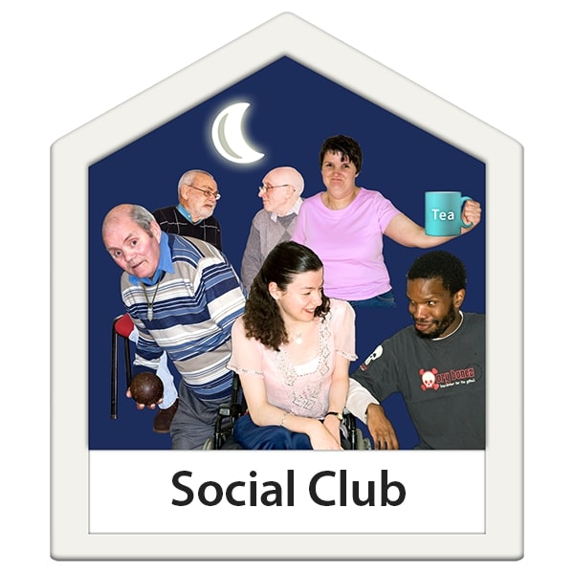
At your work, day centre, college or social club

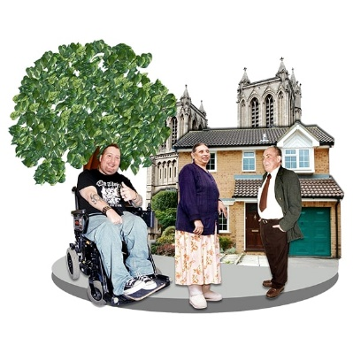
In a public place


On the internet or phone

There are different types of abuse.
Physical abuse is where someone hurts you.


It can be things like hitting, kicking, pushing, scratching, or biting.
It can also be if you are given the wrong medication, too much medication or not enough medication.

Sexual abuse can be when someone:
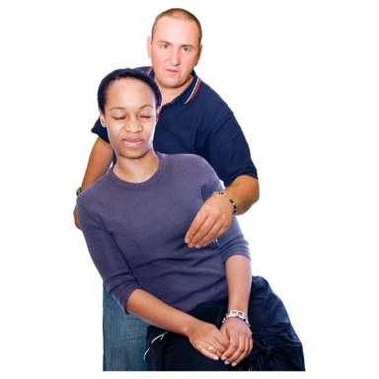
Touches your body or private parts where you do not want to be touched or makes you touch them or their private parts.
Or makes you have sex or do a sexual thing that you do not want to.


Or shows you pictures or videos about sex that you don’t want to see.

Emotional abuse is also called psychological abuse.
It’s when someone does something or says something that makes you feel bad or scared. It can be when someone who:

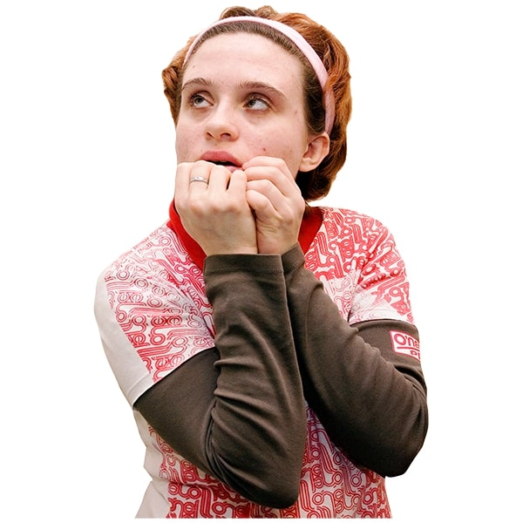
- makes fun of you
- bullies you or calls you names
- threatens you, or makes you do things you don’t want to do
- ignores you on purpose
- treats you like a child
Financial abuse can include taking your belongings, money or benefits without your permission. It might be someone who:
- steals your money

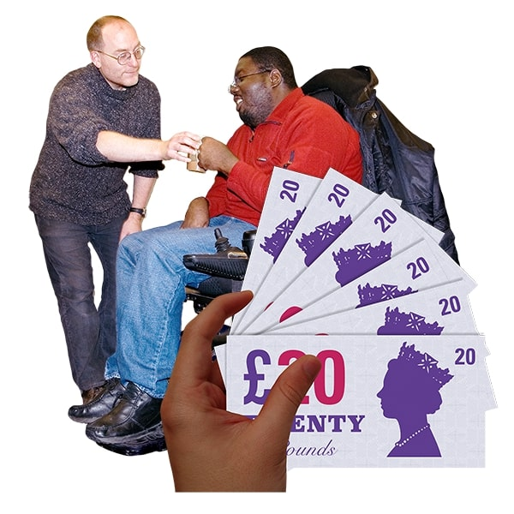
- borrows your money or things and doesn’t give them back
- makes you pay for things you don’t want to
- changes your will

Neglect is when someone who is meant to help you, does not support you properly.
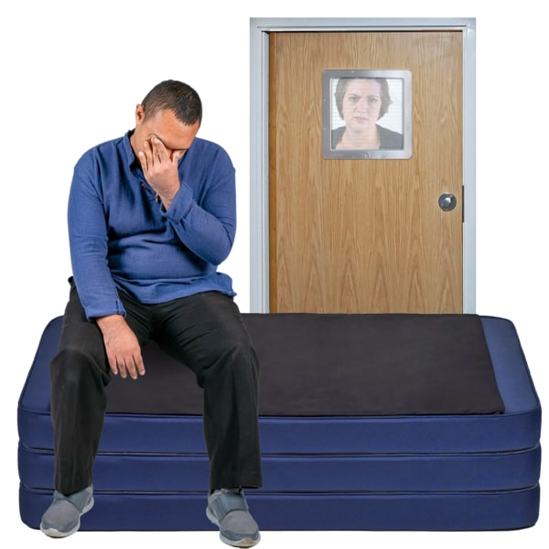
Neglect includes:

Not giving you choices or the things that you need like:
- clean clothes
- food
- the right medicine
- the right help
It also includes leaving you on your own for a long time when you need support

Self–neglect is when you are not looking after yourself properly or letting other people help you and this causes you harm.

Discrimination is when someone treats you differently or unfairly because you are different to them.
People might treat you differently because of your:
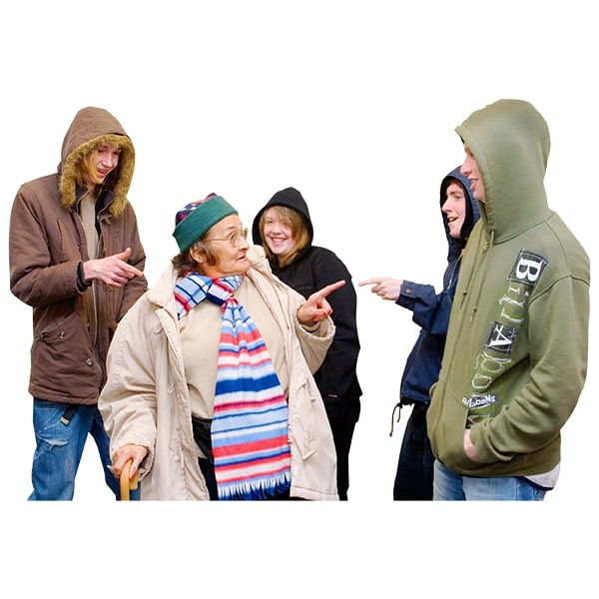
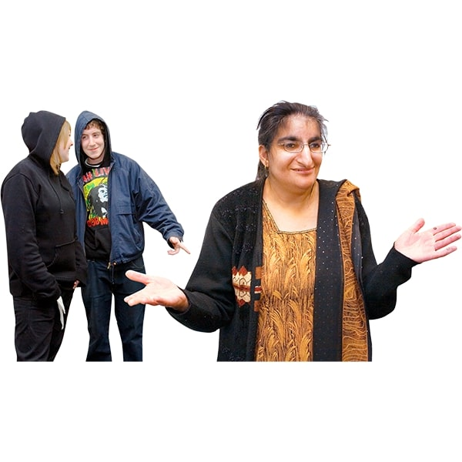
- Race or religion
- Disability
- Age
- Gender
- Sexuality
Organisational abuse can be when you are not treated properly by people who are paid to support you. It can include:
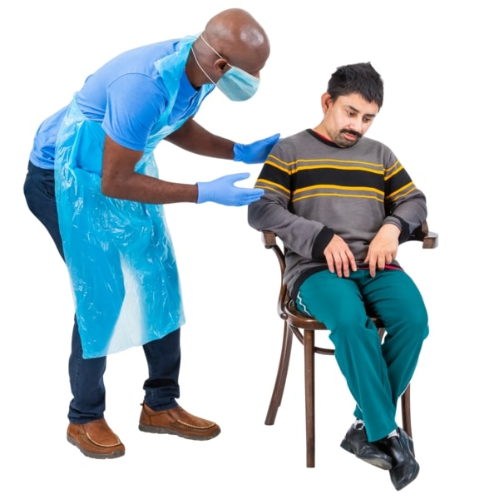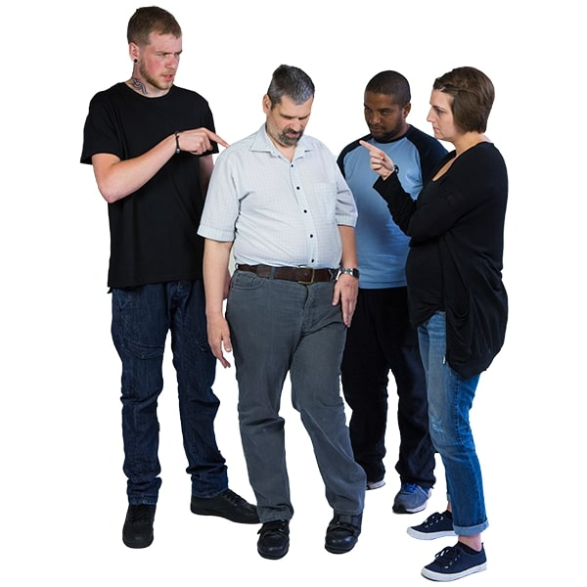
- staff make all the rules, and you don’t have choices
- staff treat you badly and have a bad attitude
- staff don’t know how to support you properly
- not having a choice of what you want to do in your own home

Domestic abuse can be when your partner or a family member hurts you in your home, makes you feel scared or forces you to do something you don’t want to do.

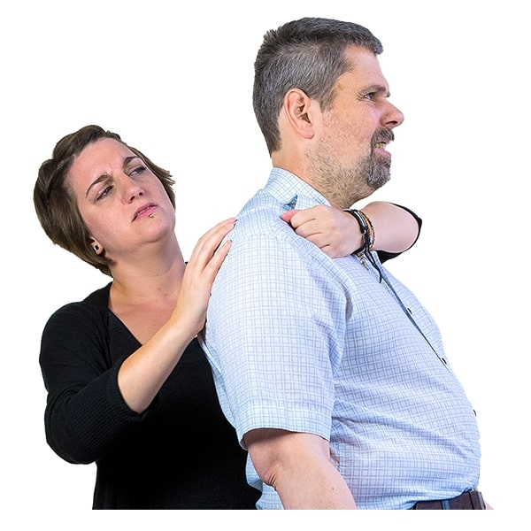
Domestic abuse can include lots of the other types of abuse in this book including
- physical abuse
- emotional abuse
- financial abuse

Modern Slavery is when someone forces you to work in a job that is against the law or does not pay you to work.
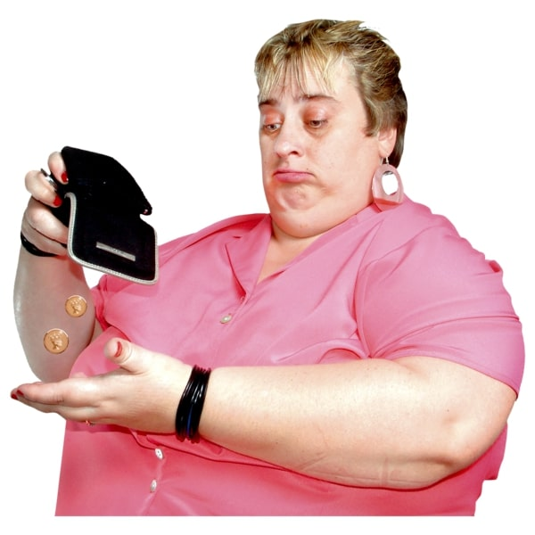
There are some other types of abuse you may not have heard of.
Hate Crime where someone hurts you or attacks you because of who you are.
This might be because of your race, disability, or something else.
Mate Crime where someone pretends to be your friend to take advantage of you.
This might be stealing your money, using your home, or eating your food.

Someone who abuses someone else could be anyone including:

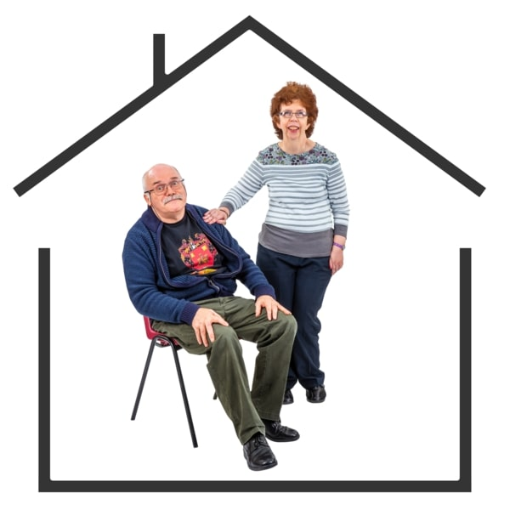
- your parents
- your staff
- your friends
- your college tutor
- a stranger
- someone else
Remember that no one should ever abuse you and you have a right to be safe at all times.

Abuse and neglect is never ok.

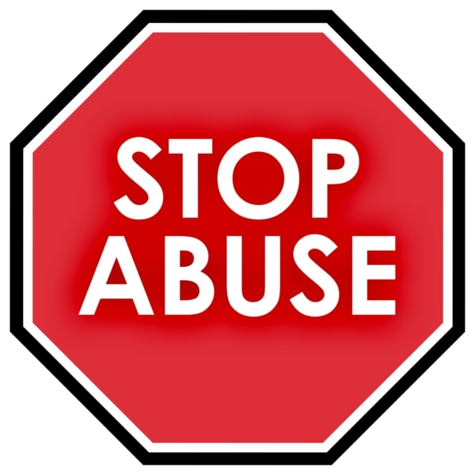

If you think you are being abused
Tell someone you trust
This could be:

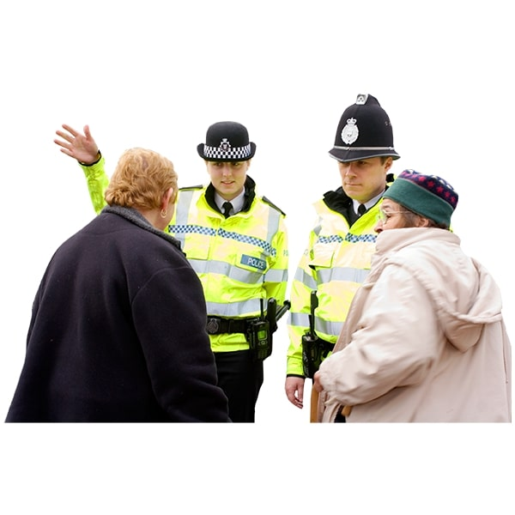
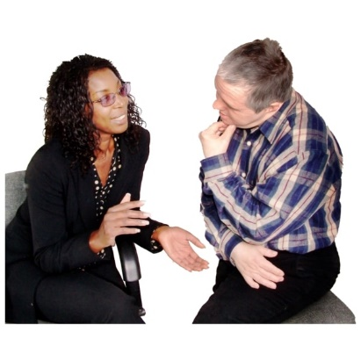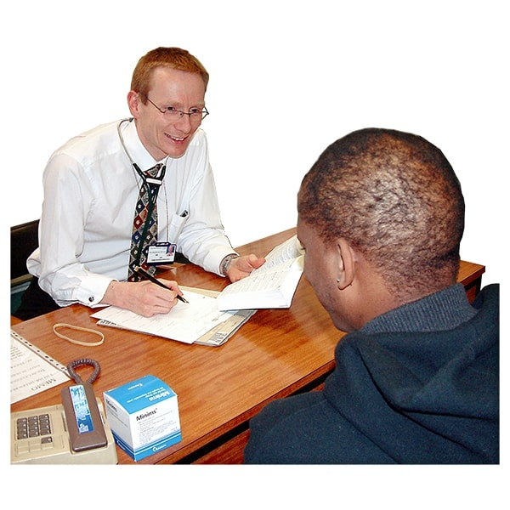
- A member of your family
- A friend
- A carer or support worker
- Your social worker
- An advocate
- The police
- A nurse or doctor
- An inspector from CQC
- Someone else you trust

Get in touch with us if you are worried about something


07368815456

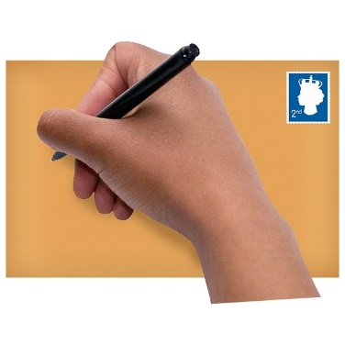
1 ford street, Kinsley, WF9 5ED


Chris.storer@kinwoodcare.co.uk

Or phone:
Local Authority Safeguarding Team- 03458503503


